**Get token End point**

**Validate if Http Headers and Http contents are correct then success Response with status code 0 and Http code 200 :**

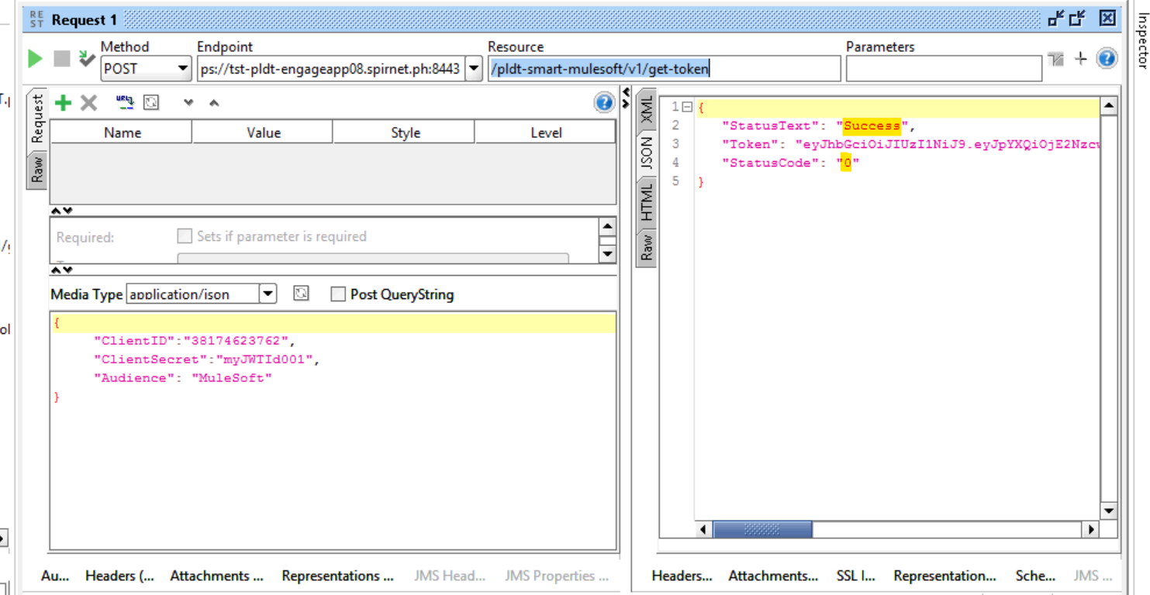

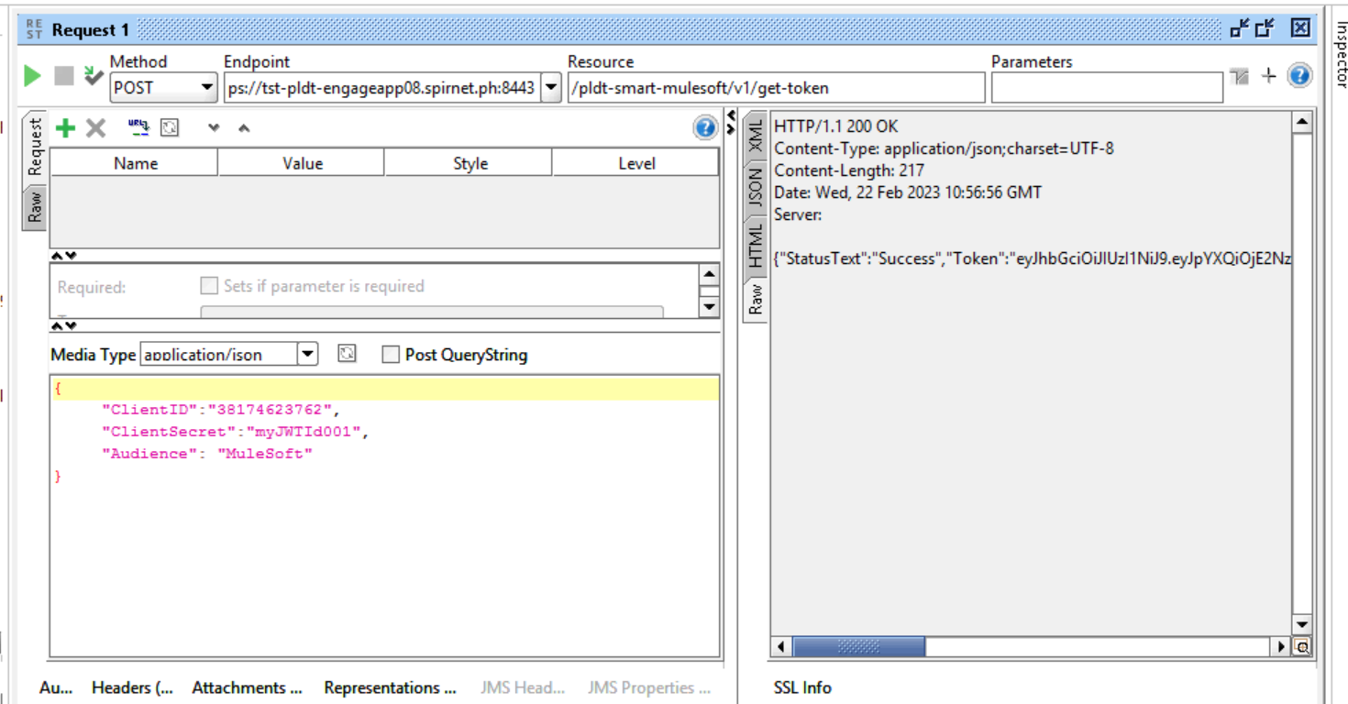

**Validate if Http Headers and Http contents are incorrect then Failure Response with status code 1000 :**

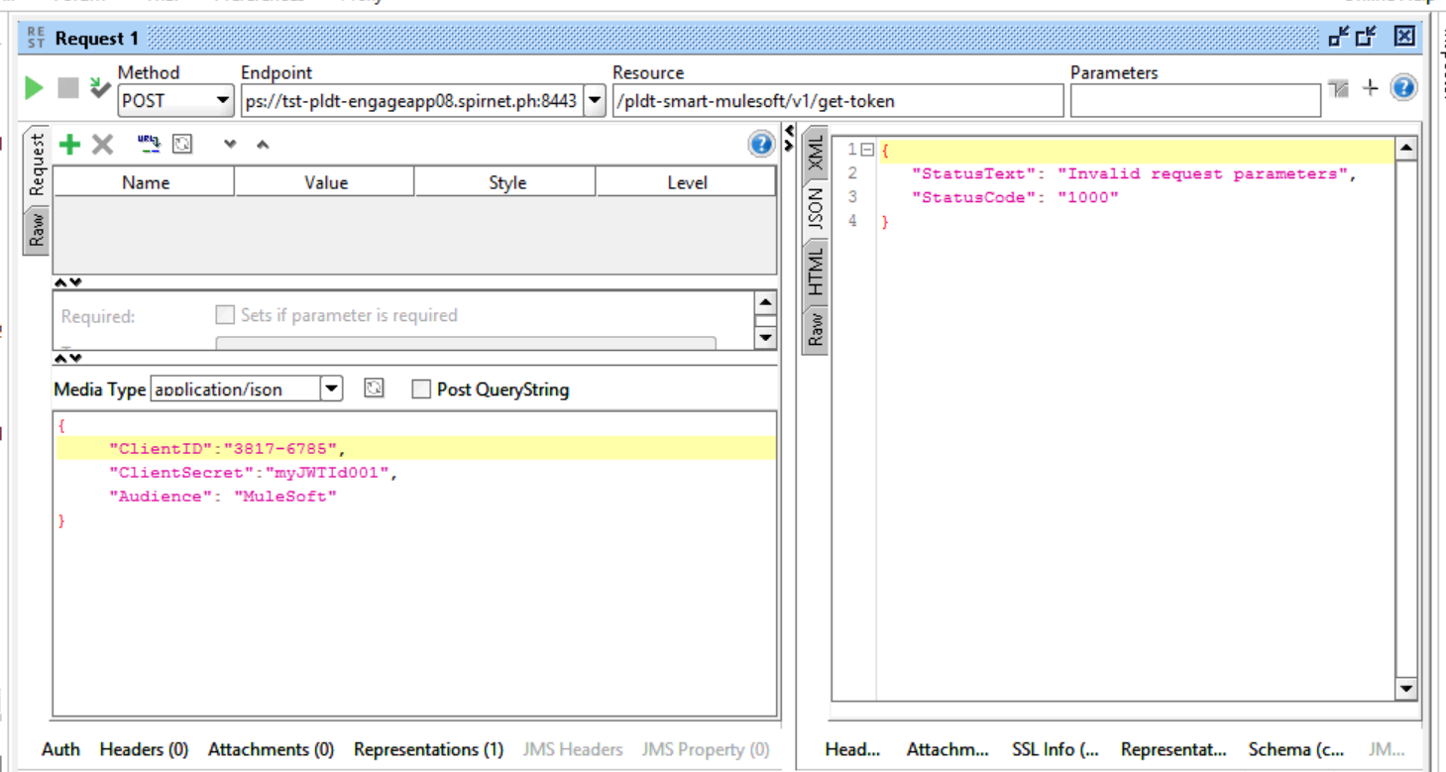

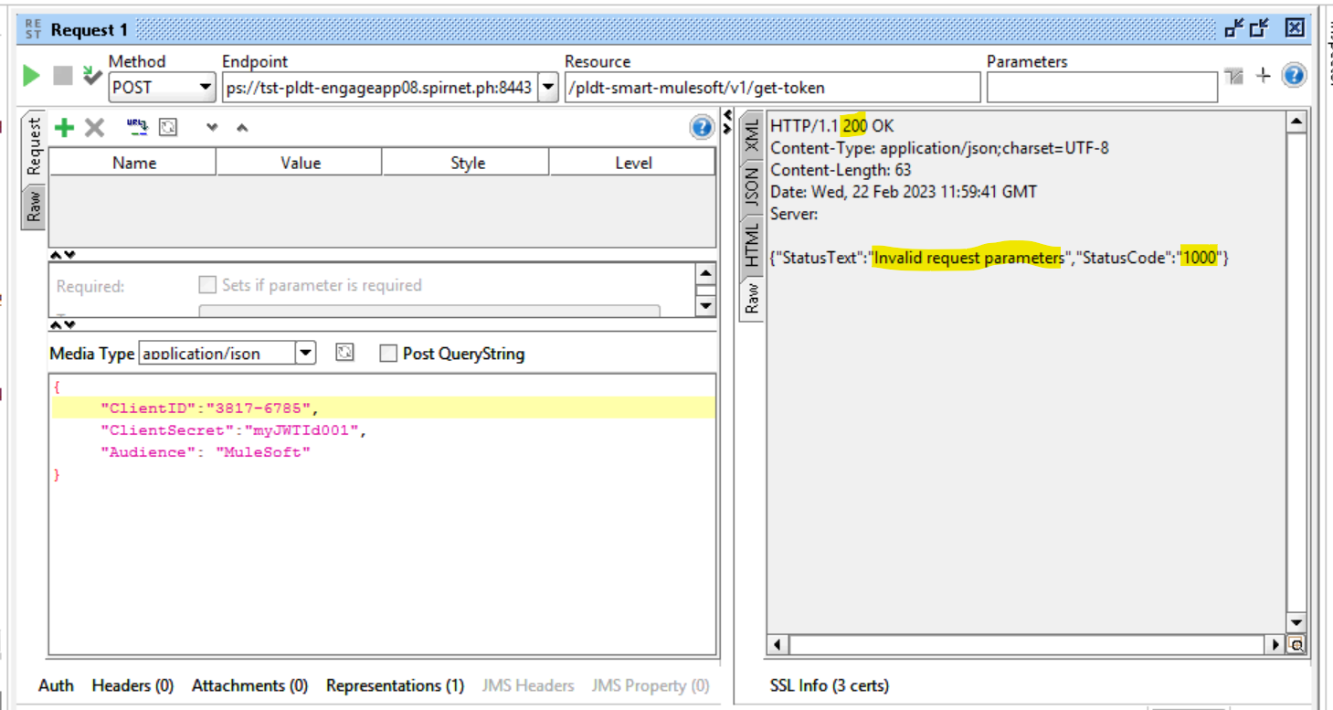

**Notification End point:**

**Validate if Request parameters are correct then status code in Response is 0 :**

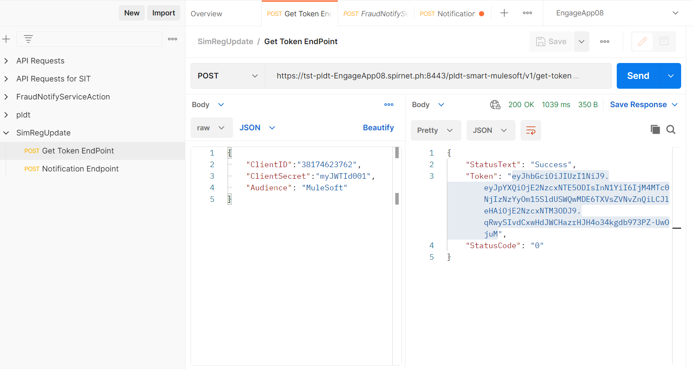

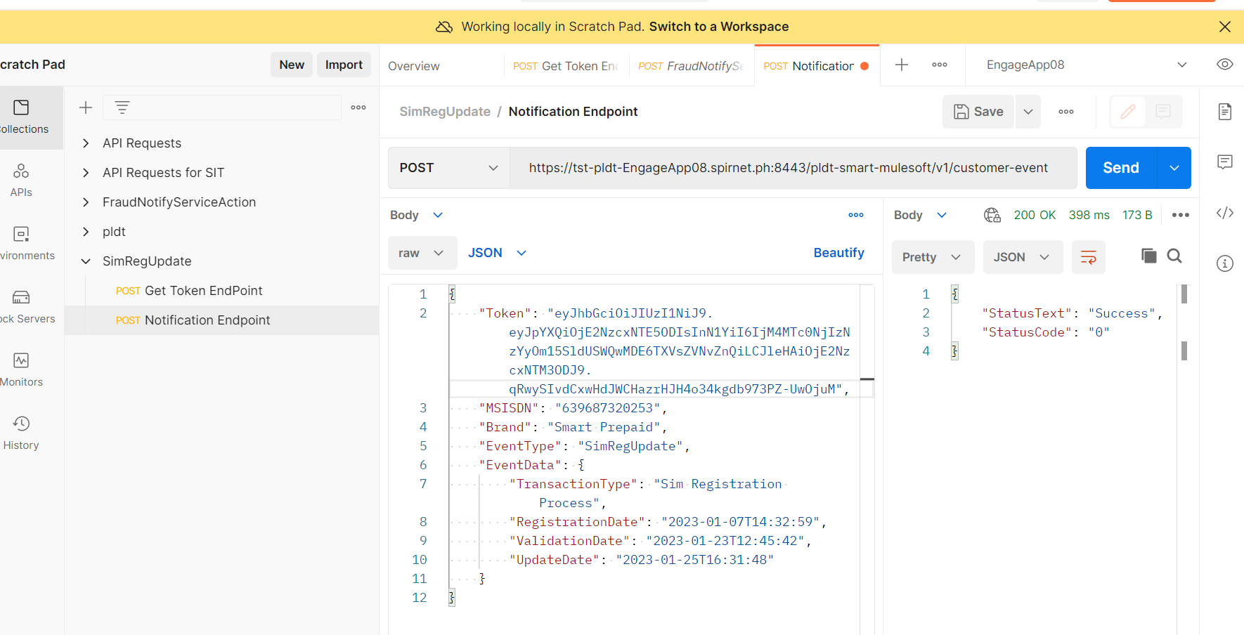

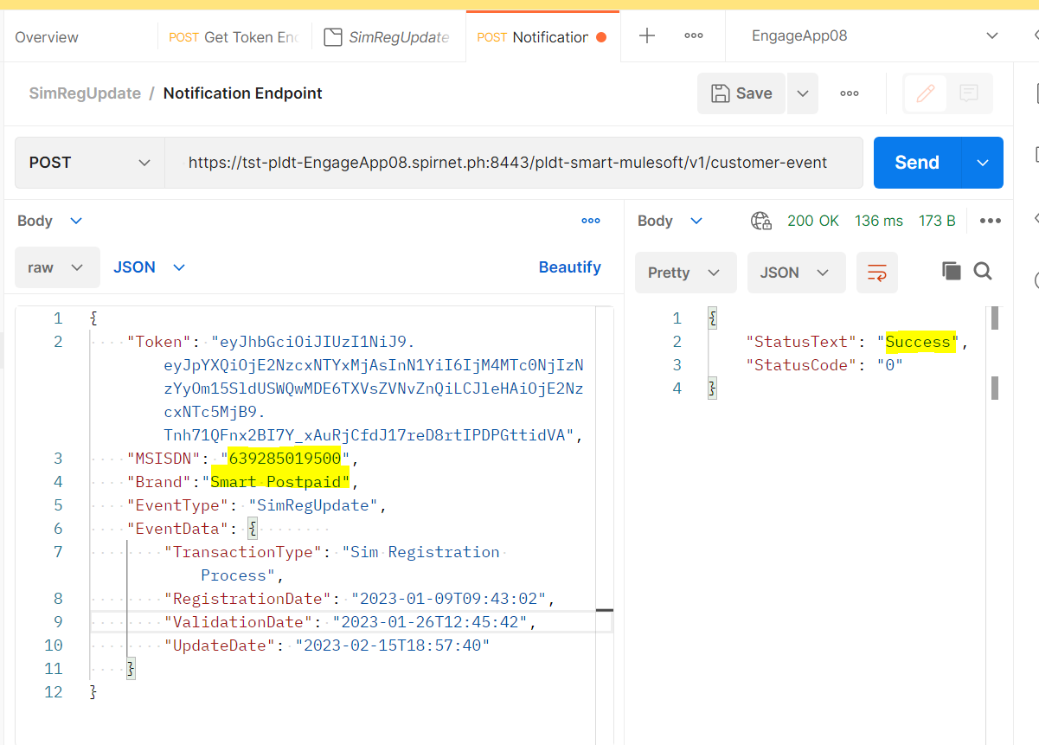

**Invalid character in Token :**

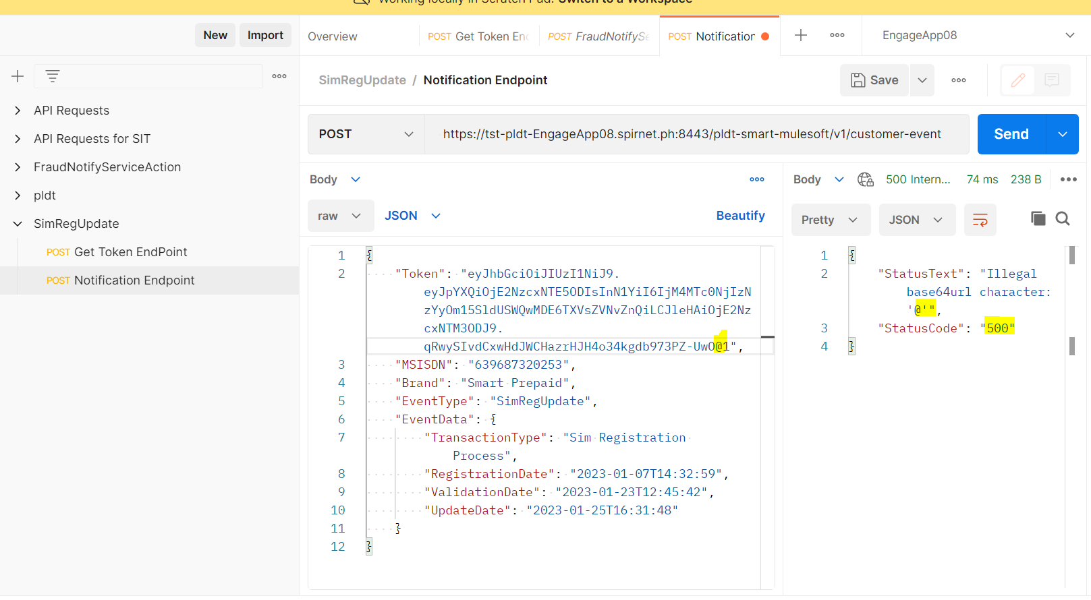

**Invalid Token :**

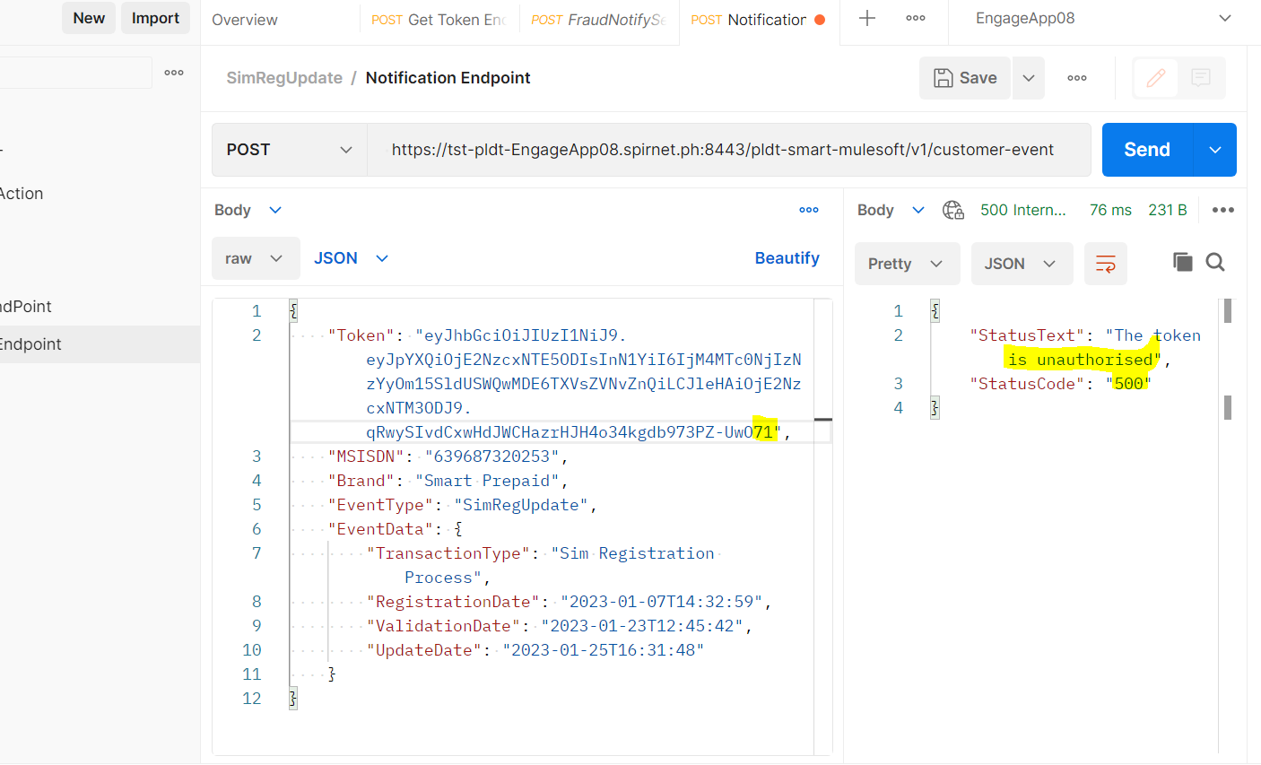

**Validate if Request has NULL inputs then status code in Response is 101**

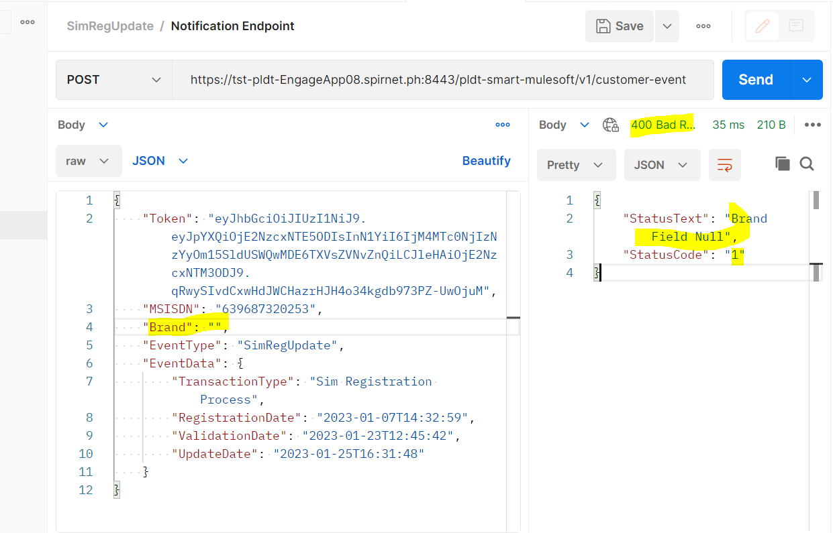

**Validate in Request if MSISDN not found then Response status code is 101 :**

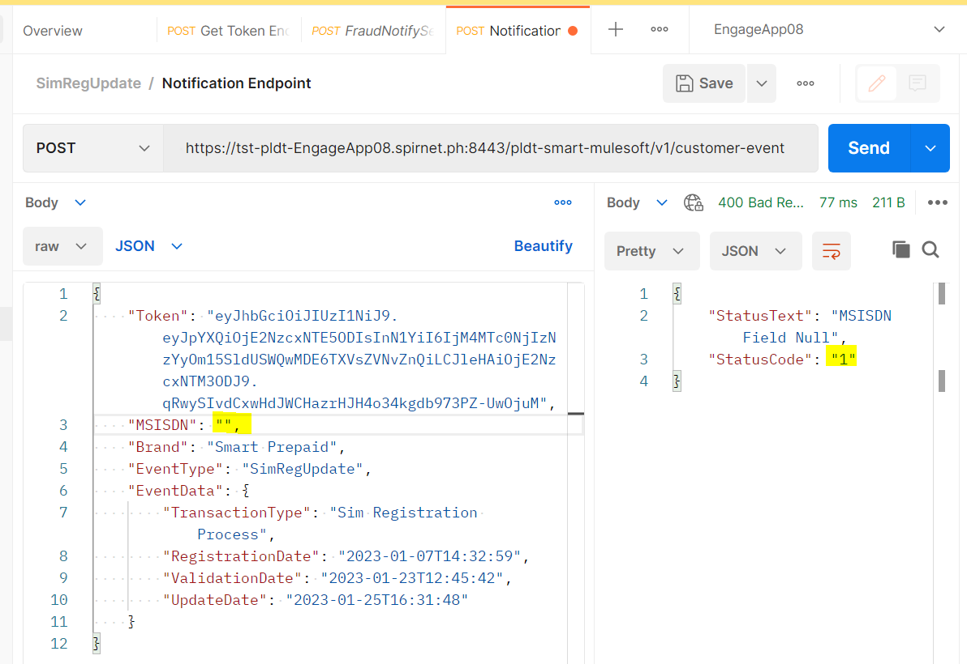

**Validate if Request has incorrect inputs then Response has Http code 400 :**

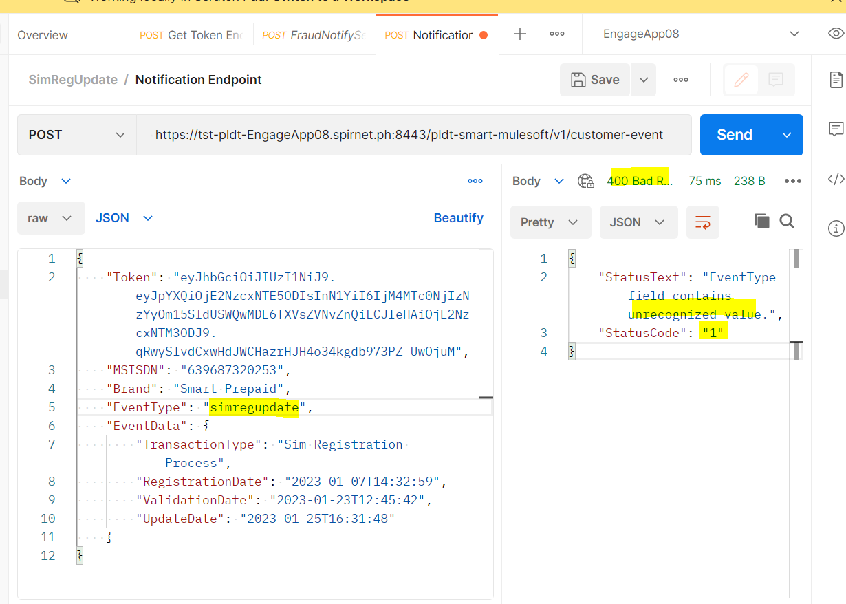

**Validate if token is Expired the Response with status code 103 and Http code 200 :**

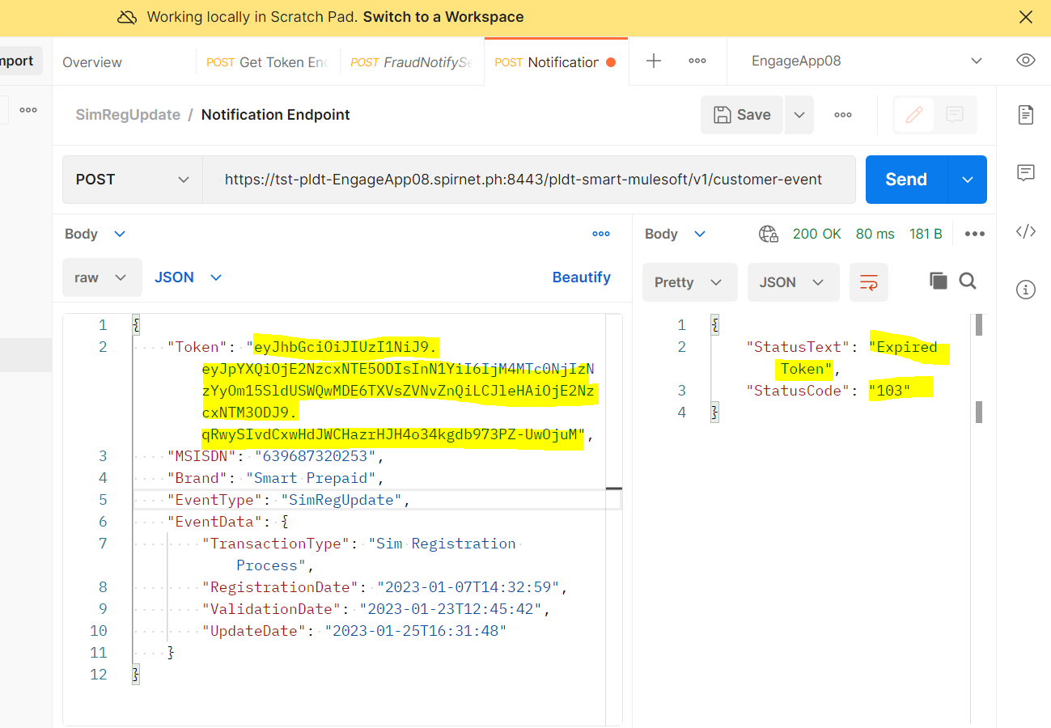

**Validate if Request has incorrect Date format then Response has Http code 400 :**

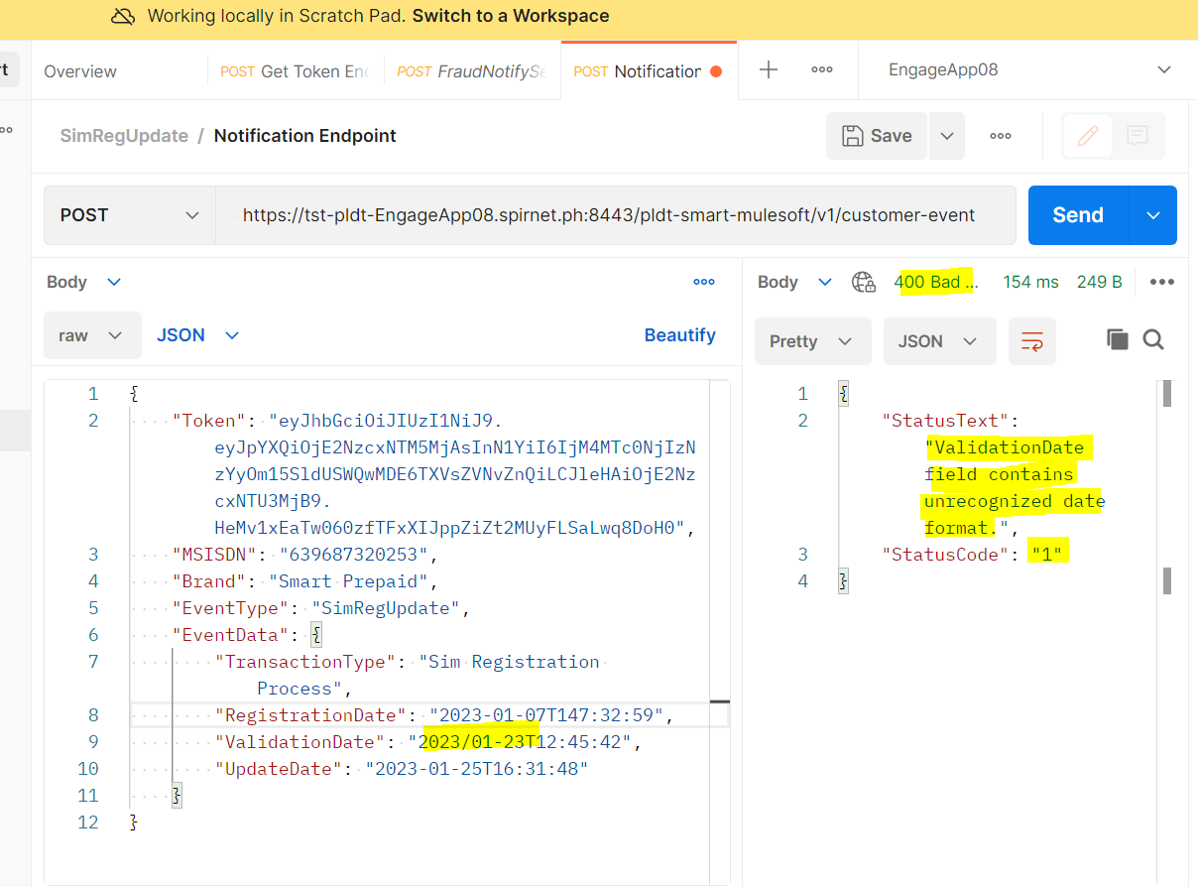

**If MSISDN is not in international Format :**

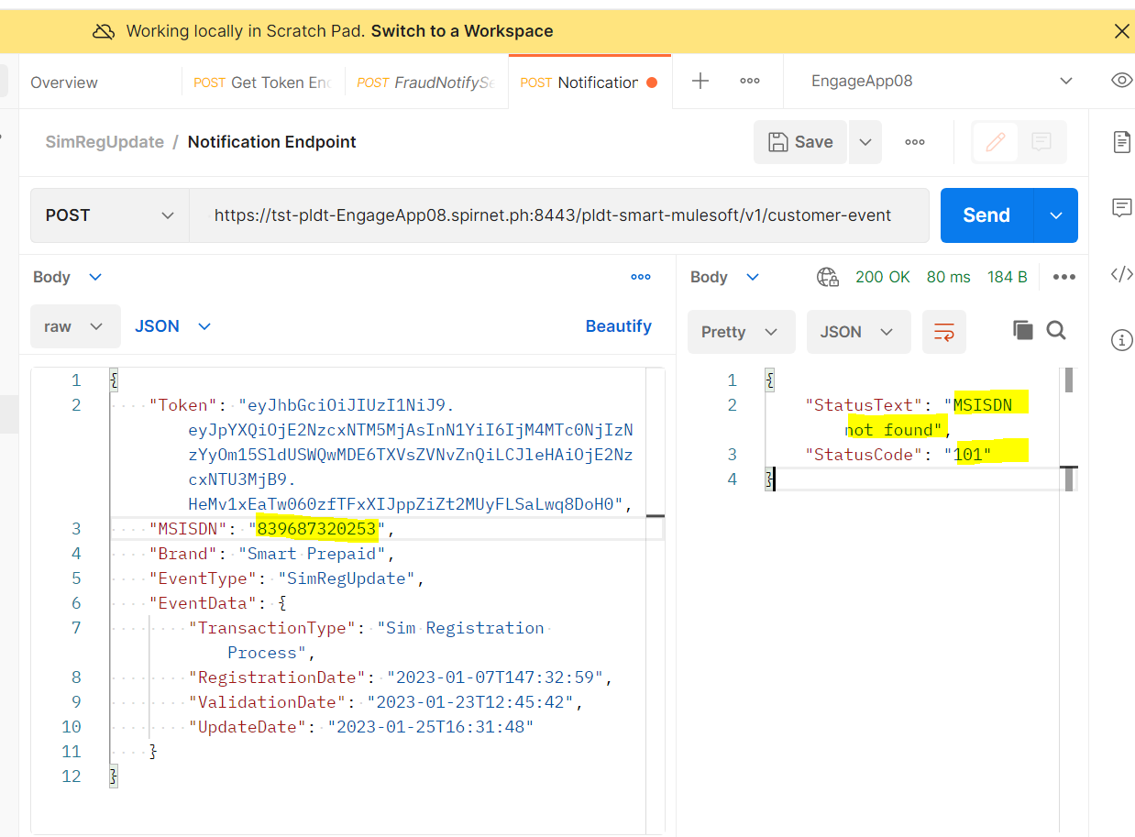

**Validate if Request has invalid MSISDN (non– numeric values) then Response has Http code 400 :**

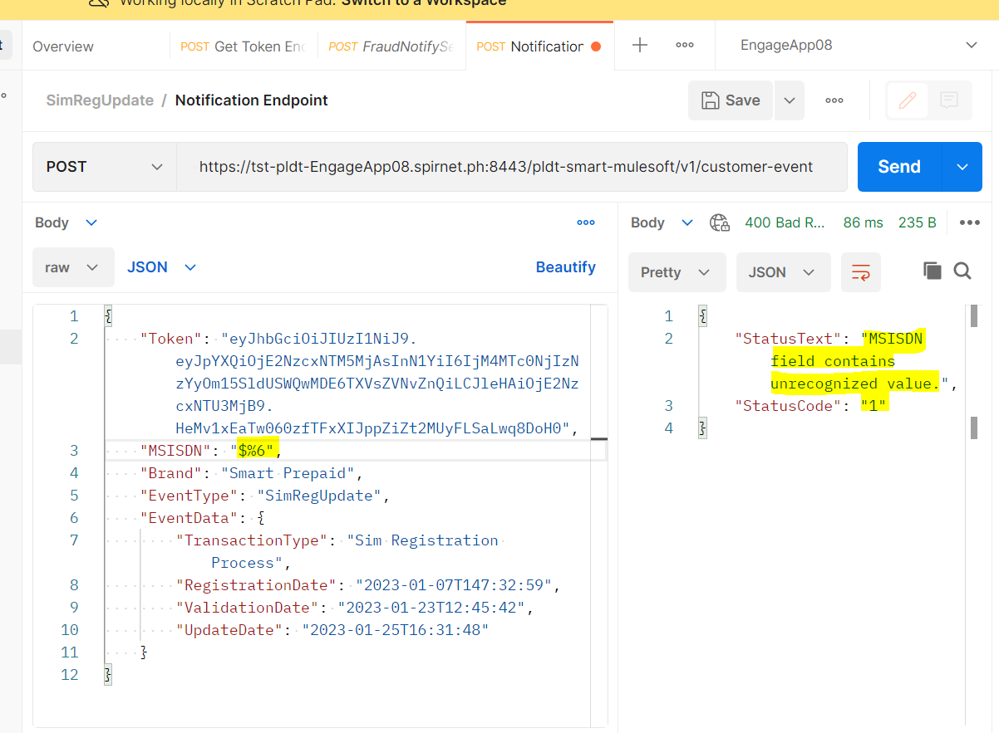

**For Prepaid MIN if we keep postpaid as brand :**

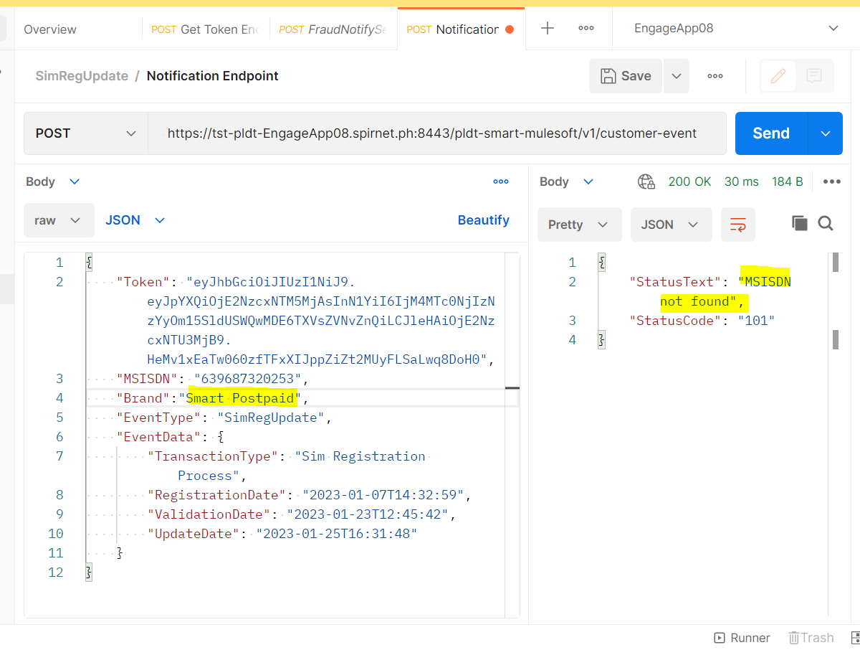

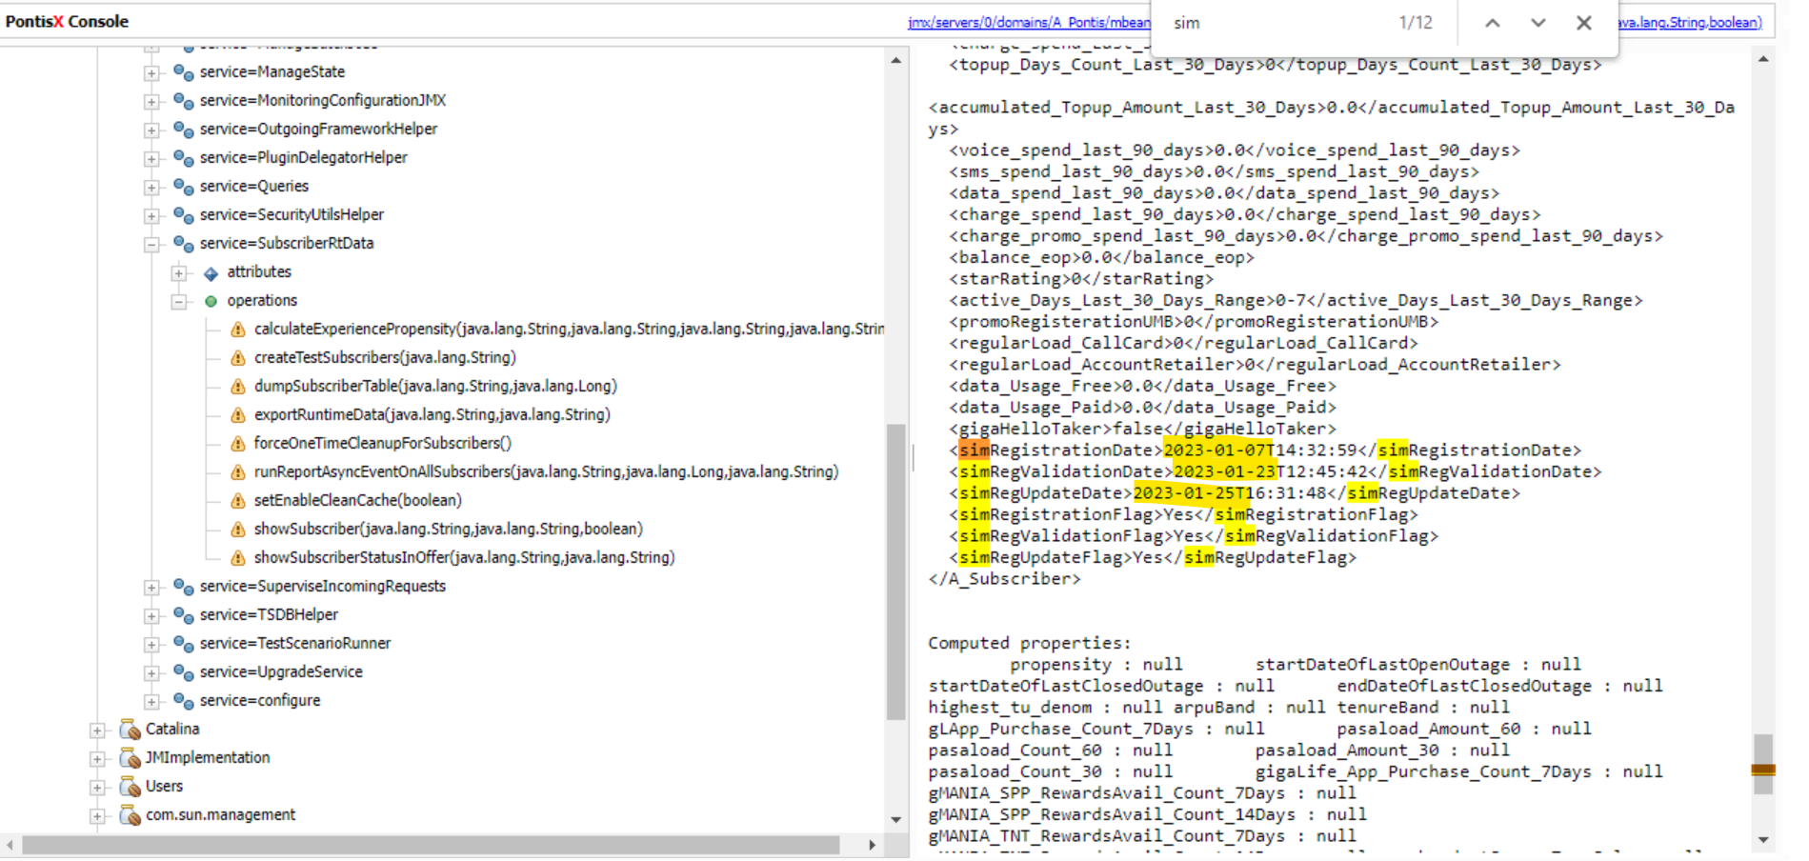

**Home Brand:**

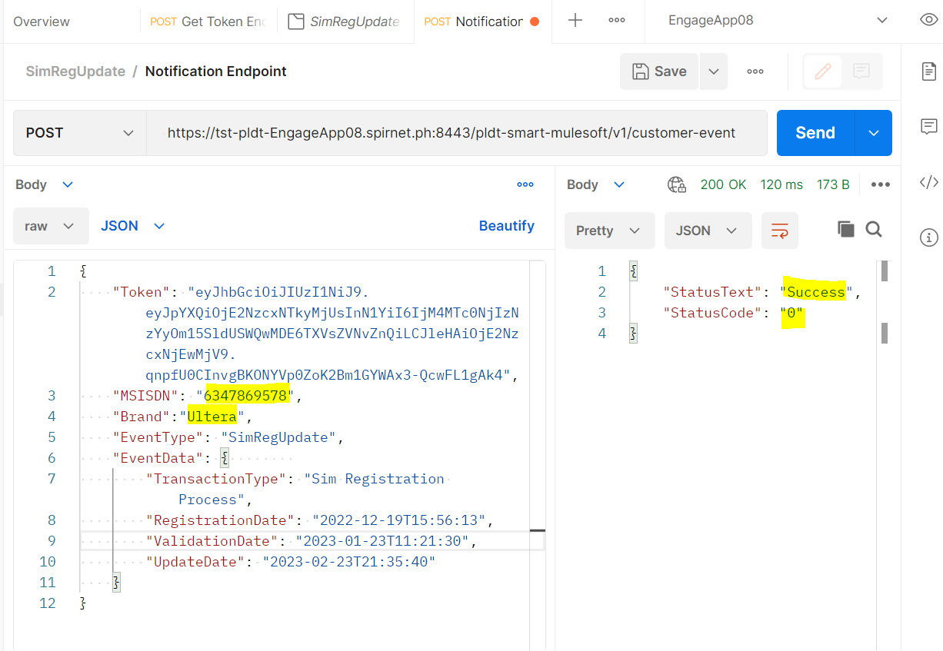

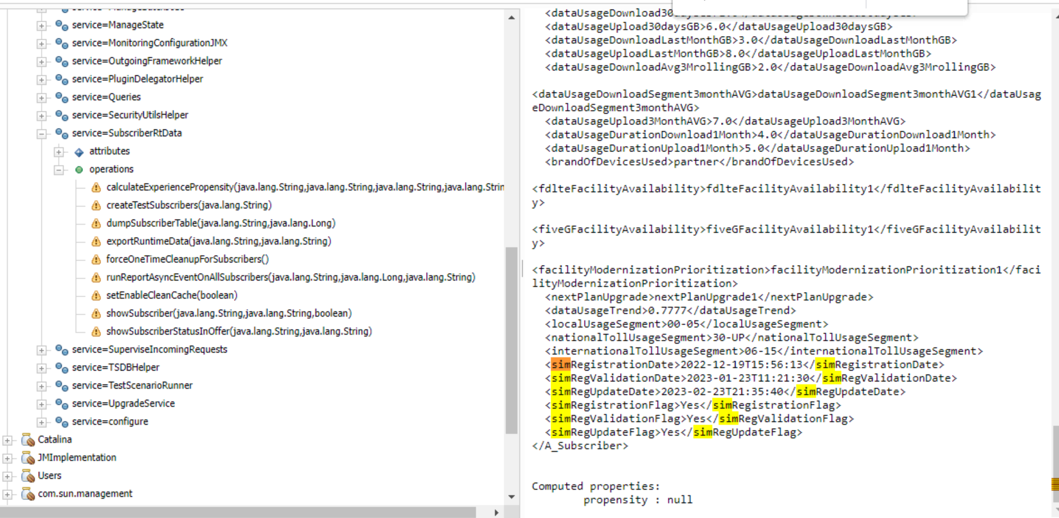

**For postpaid MIN if we keep brand as prepaid :**

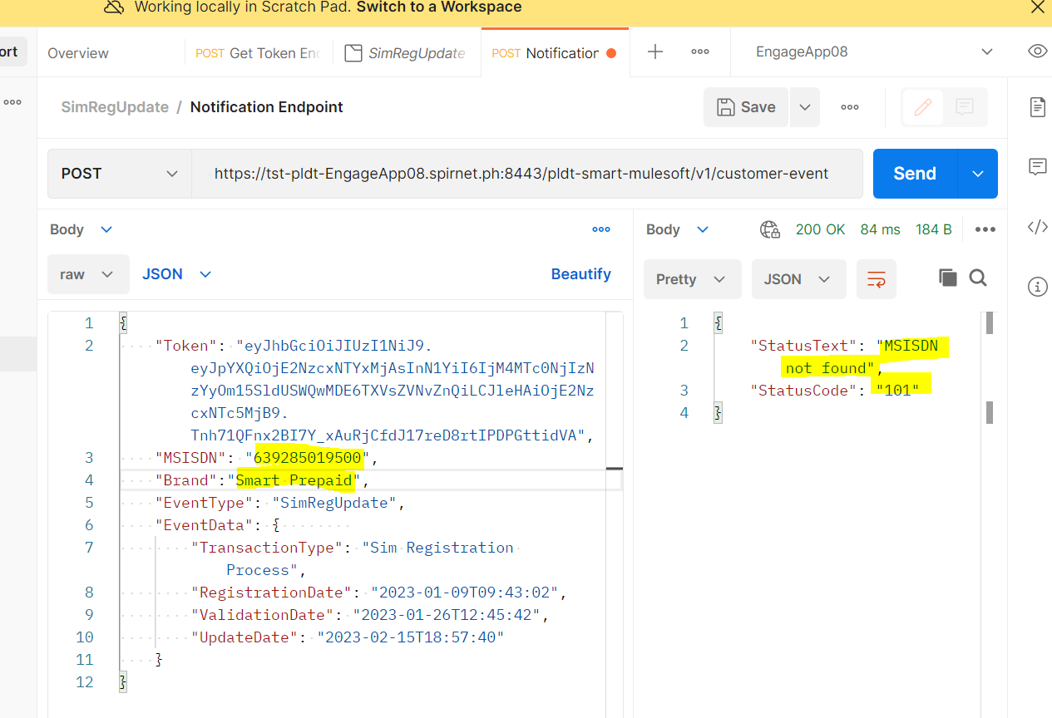

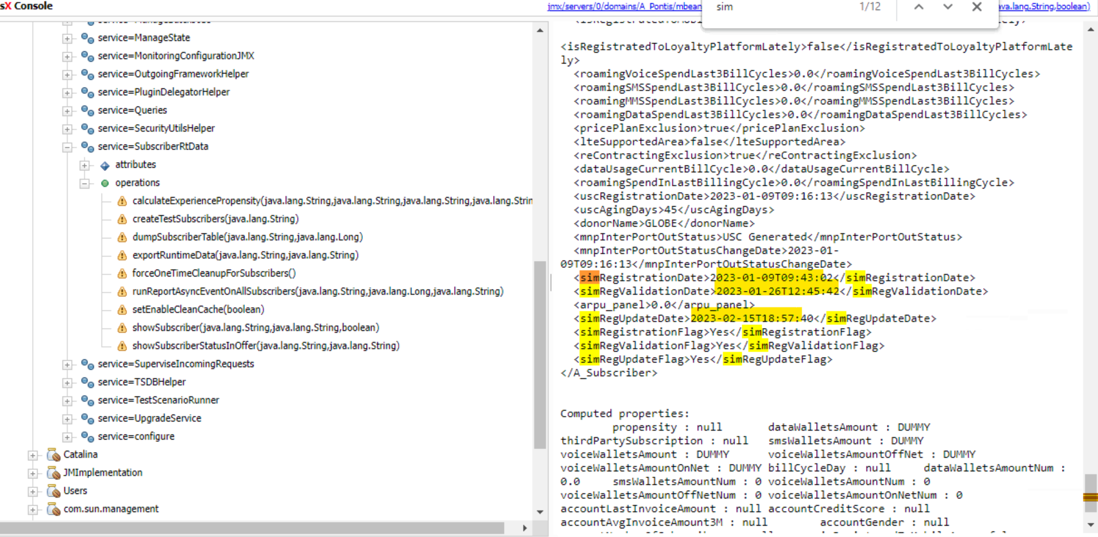

**Transaction type:**

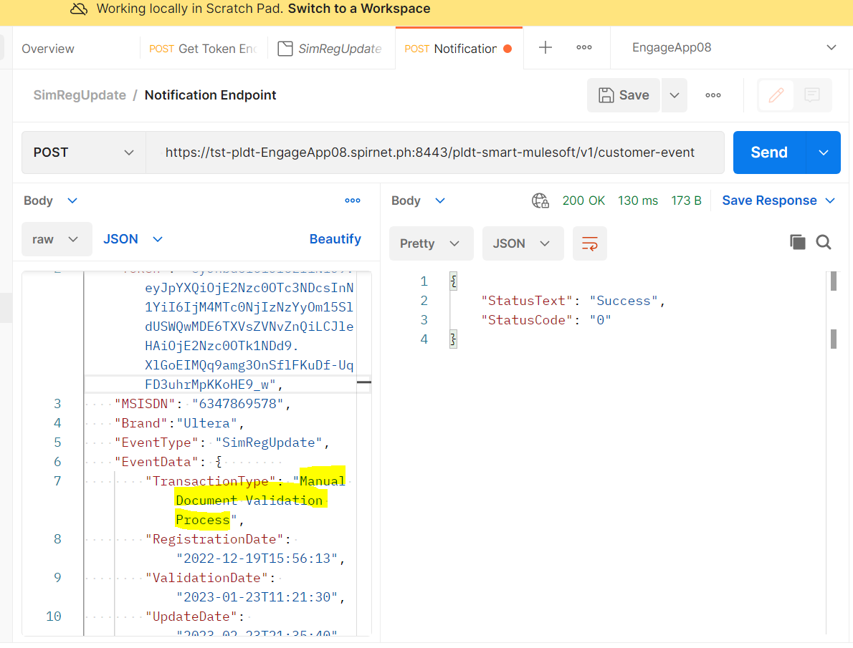

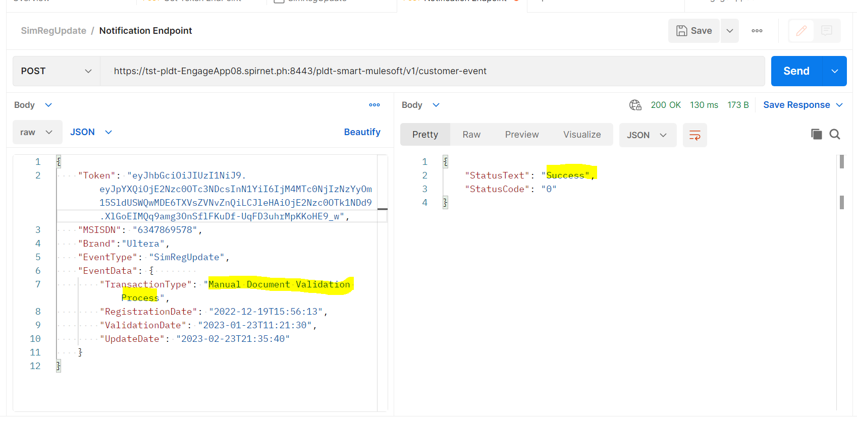

**Sim Registration Update process:**

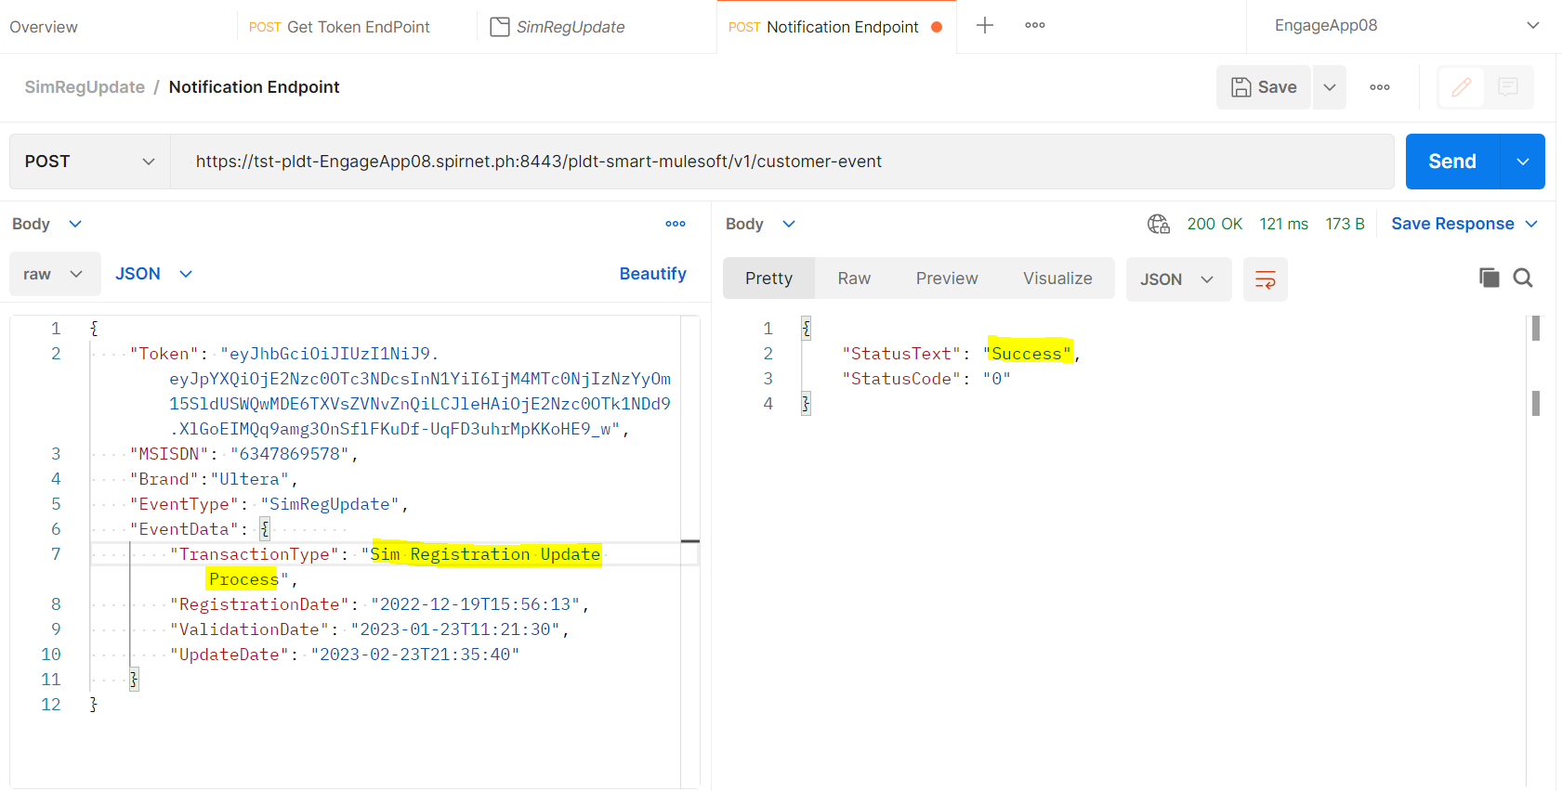

**Validate with wrong field in Transaction type :**

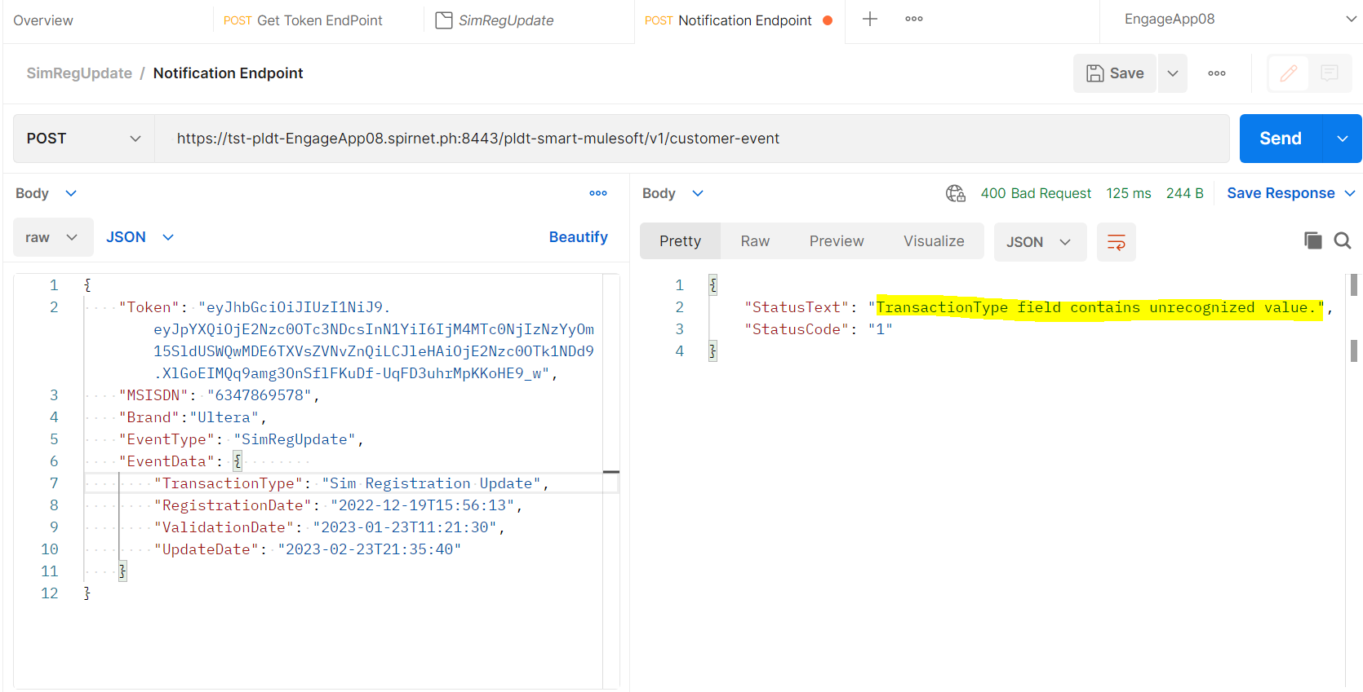

**Fallout Scenario (SIT )**

|  |
| --- |
|  |

|  |
| --- |
| verify the file format "Mulesoft_#name_#time.csv" |
| Validate whether input file is in incoming path |

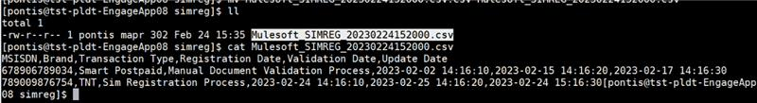

|  |  |
| --- | --- |
| Run the CDR File Processor Job / | SIMRegUpdateFileProcessor file |

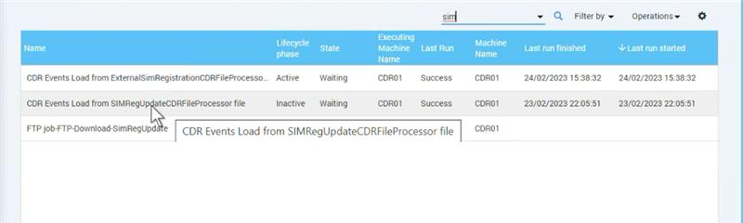

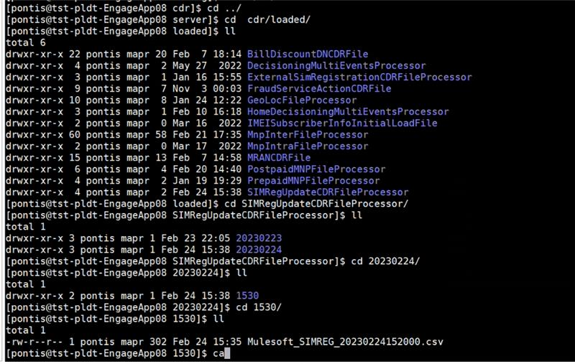

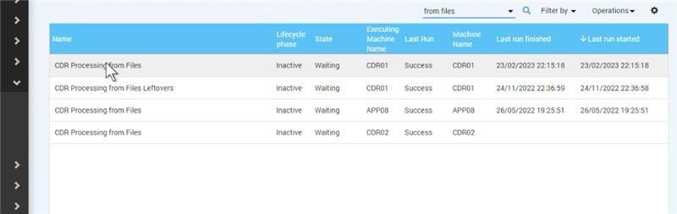

|  |
| --- |
| File in loaded |

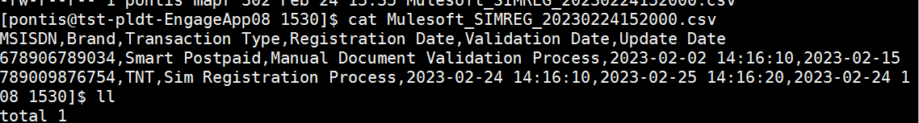

|  |
| --- |
| File processed successfully and loaded to processed |

For Prepaid

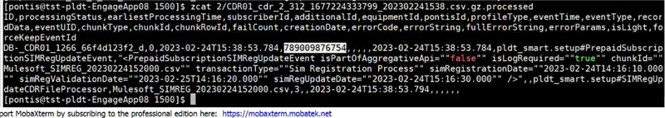

 For Postpaid

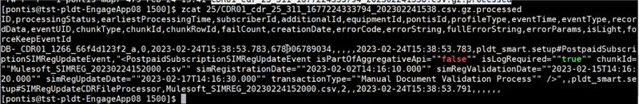

 For HOme

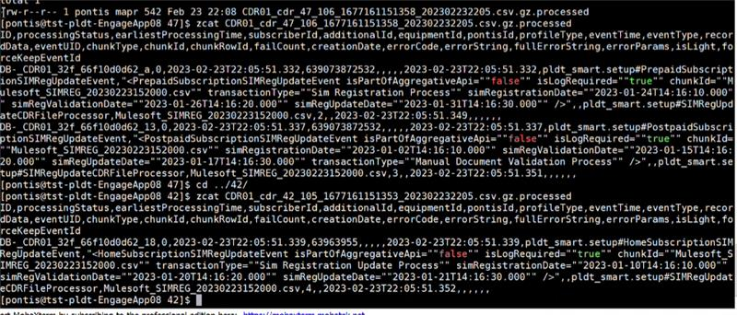

**Validating the attributes in jmx**

|  |  |
| --- | --- |
| Prepaid | Validated |
| Postpaid | Validated |
| Home | validated |

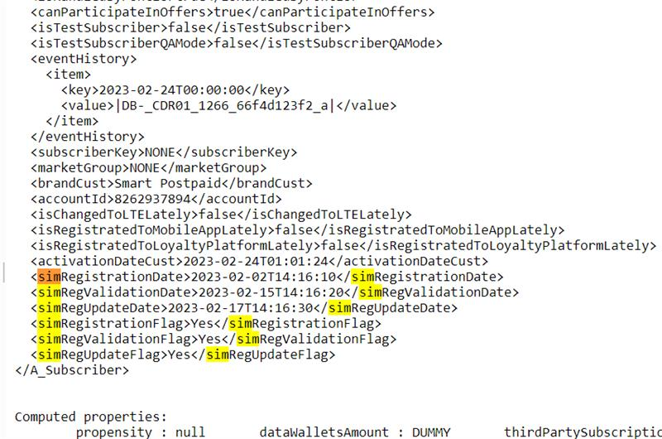

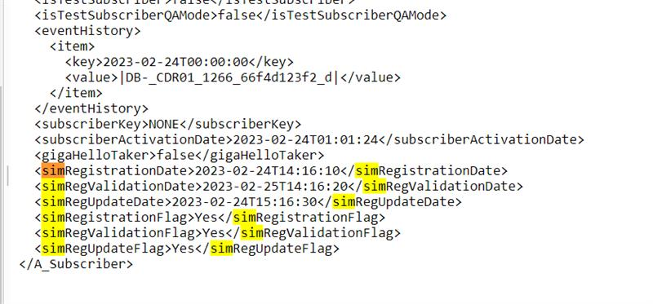

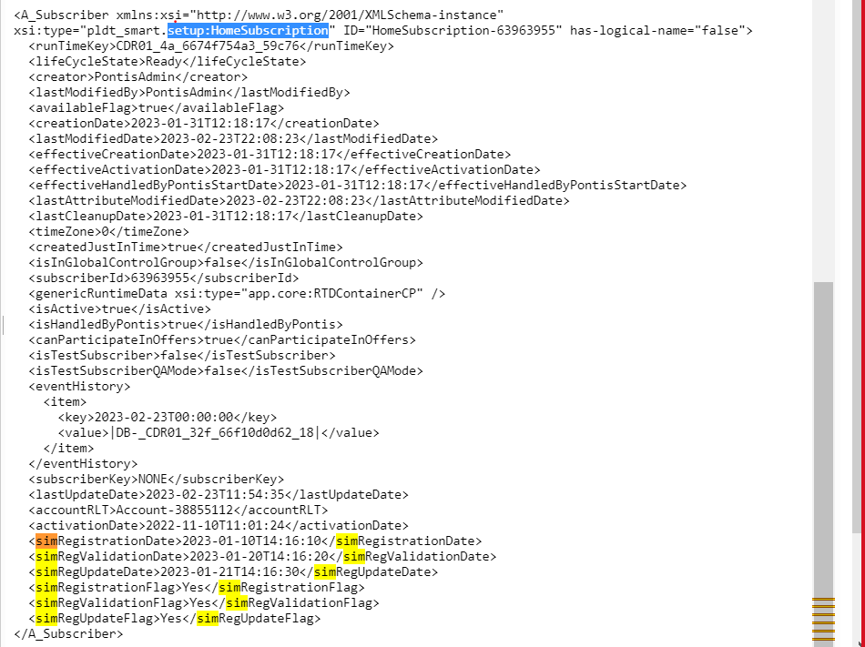

**Validating the attributes in hive**

|  |  |
| --- | --- |
| Prepaid | Validated |
| Postpaid | Validated |
| Home | validated |

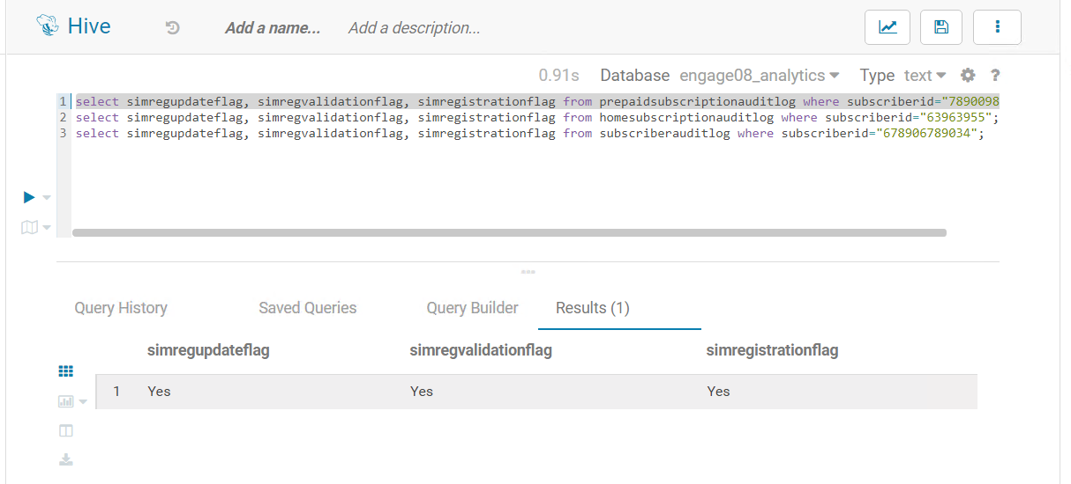

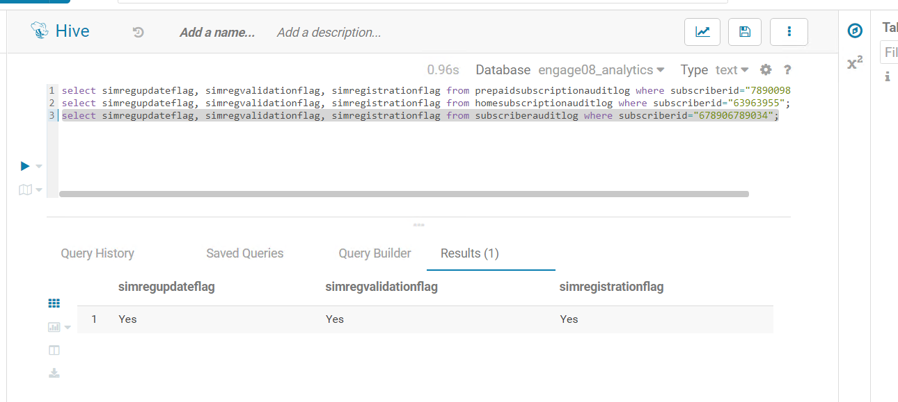

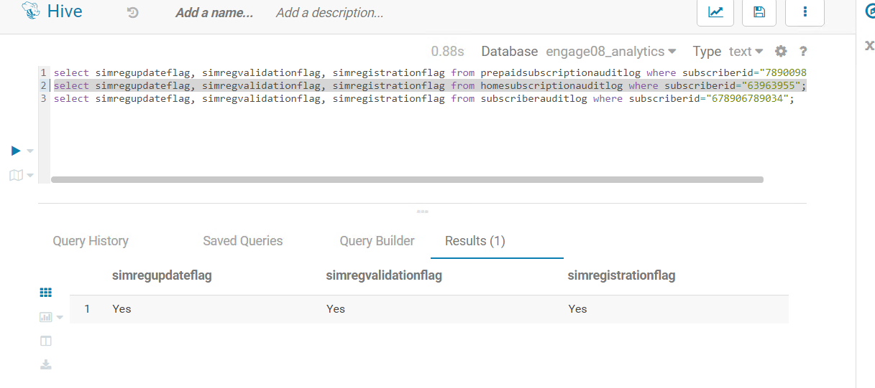

|  |  |
| --- | --- |
| Validating Header | Yes |



|  |  |
| --- | --- |
| Using Invalid and empty brand | File is in error_in_load |
| Using invalid TransactionType | File is in error_in_load |

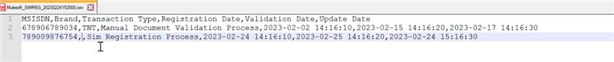

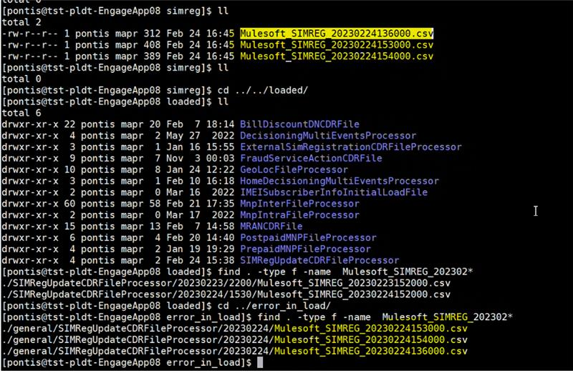

 FTP Scenario:

Create a file in the path cd /adh/fsuser/pldt/interfaces/SITAPP08/mulesoft/simreg

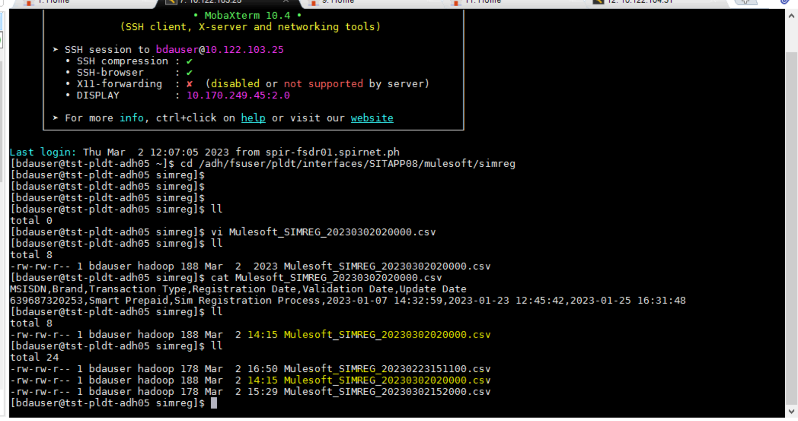

Run the FTP Job:

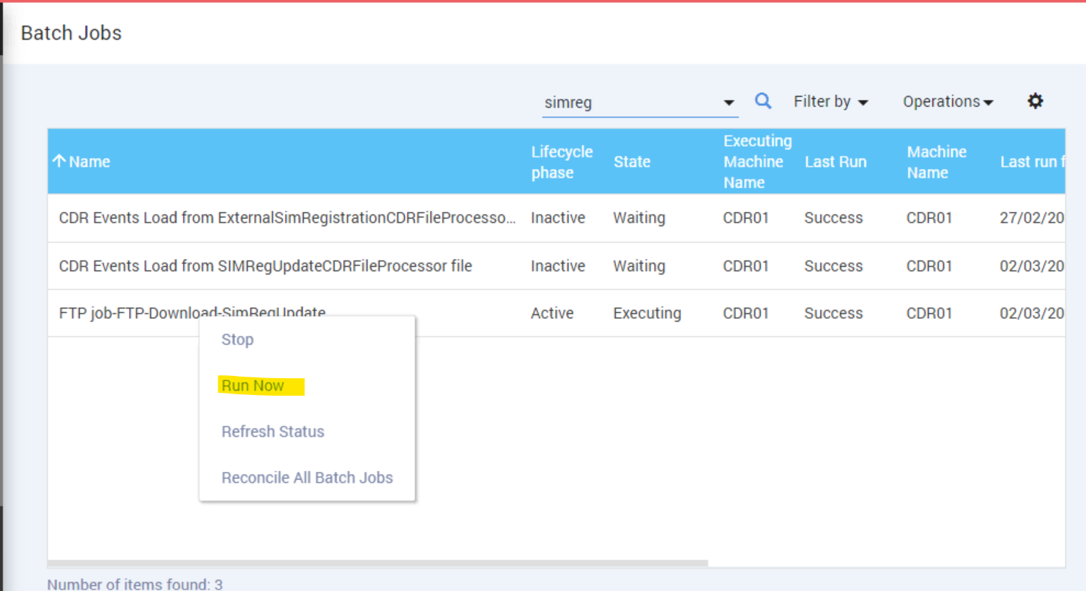

File got Dumped into correct path (cdr/incoming/simreg):

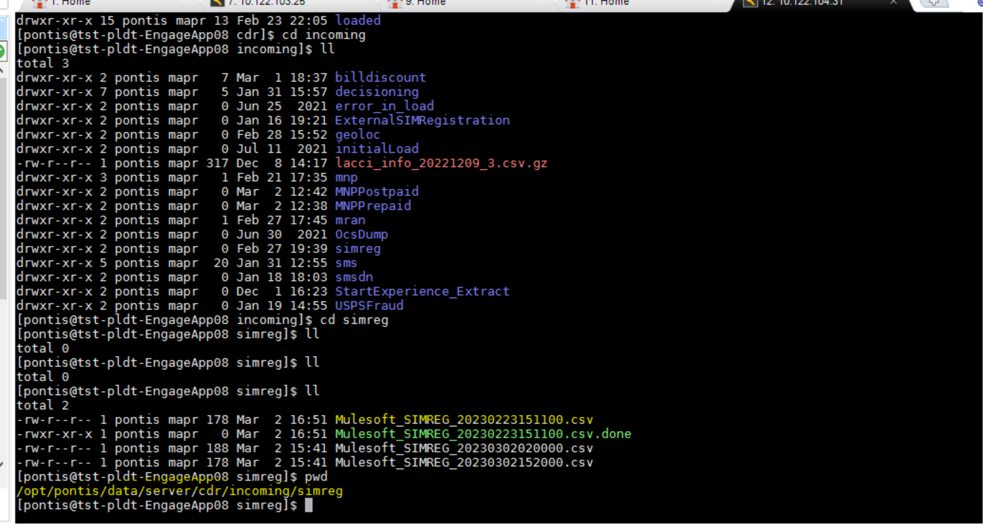

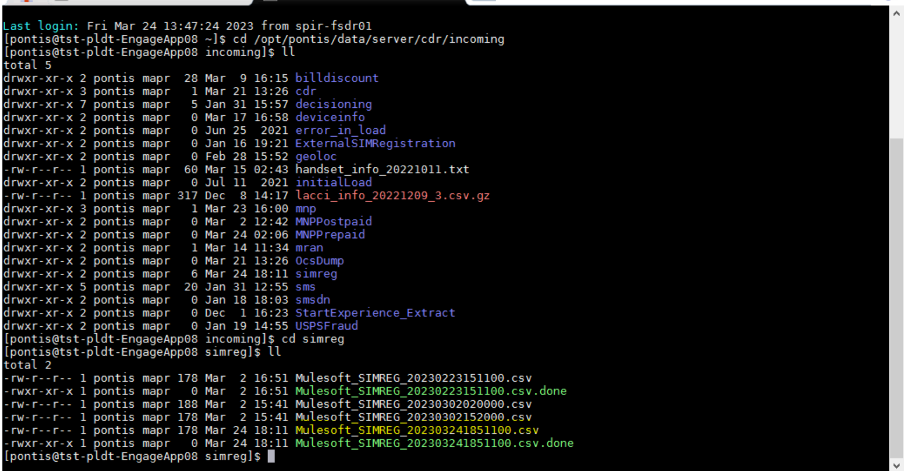

**IAT FTP SCENARIO :**

